# 

## **Q1: Multiple Linear Regression – House Price Prediction**

## **Python Code**

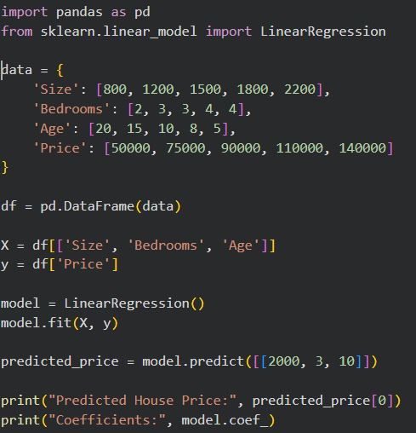

**Output**



## **Q2: Multiple Linear Regression – Student Performance**

**Python Code**

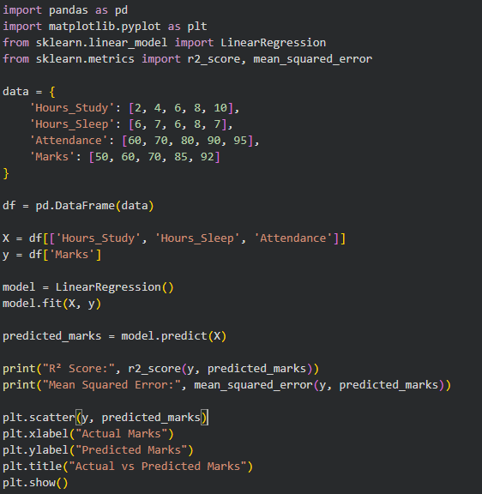

### 

### 

### 

### **Output**

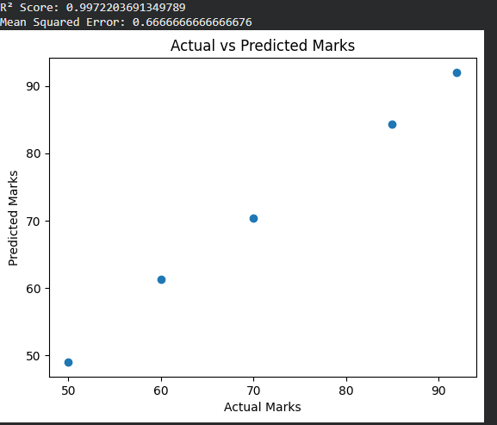

## **Q3: Logistic Regression – Pass / Fail Classification**

**Python Code**

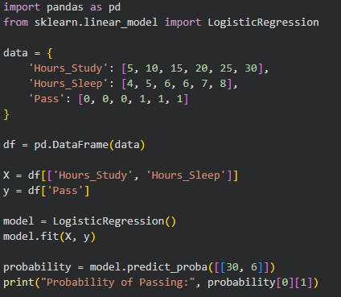

### **Output**



## **Q4: Logistic Regression – Diabetes Prediction**

**Python Code**

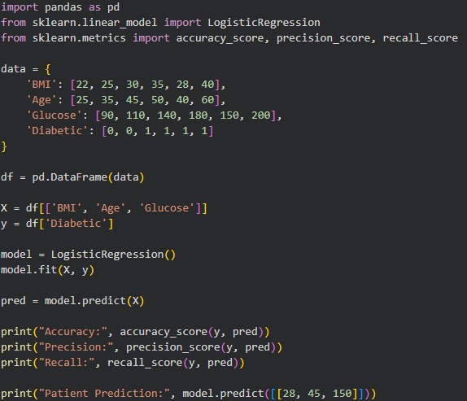

### **Output**

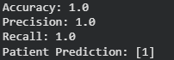

## 

## 

## **Q5: Comparison – Linear vs Logistic Regression**

### **Explanation**

* **Linear Regression** predicts continuous values
* **Logistic Regression** predicts probabilities and classes
* Linear regression is **not suitable for classification** because it does not limit outputs between 0 and 1